'Operations in North Africa and the Middle East'

A collection of official Despatches - Commanding Officers' reports - brings together invaluable historical source material
MAR 5

SAVE |  | ▷ LISTEN

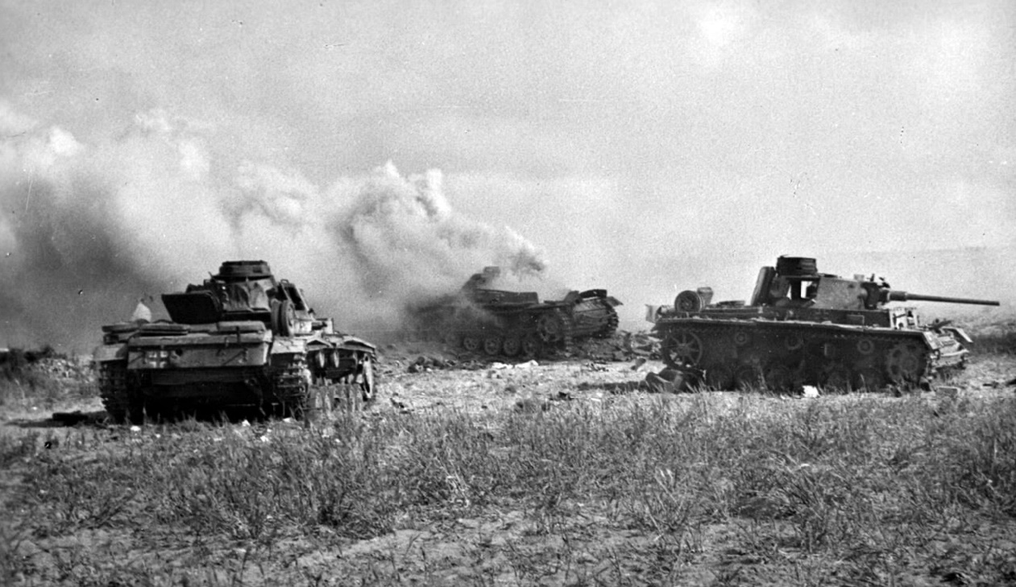
German panzers burning after the Battle of Medenine.
Just republished by Pen & Sword is a very useful collection of reports on the war in Africa. Operations in North Africa and the Middle East 1942-1944, El Alamein, Tunisia, Algeria and Operation Torch consists of copies of the official reports written just after the campaigns by the most senior commanders in the field. These have been publicly available for some time - but that usually meant a personal trip to the archives. Having them collected together in print is therefore a great help to students of military history, and anyone who wants to get to grips with a particular campaign.
These are all factual accounts of ‘what happened’ seen from the perspective of the High Command - but they are by no means dry documents. They provide much context about the situation faced by the British Army and the Royal Navy at the time - and the many factors that each of the commanders had to take into account when deploying his forces.
The following excerpt gives a flavour of how these reports read. This is from Field Marshal Alexander’s Despatch on the African Campaign: covering the period of the 5th-6th March 1943:

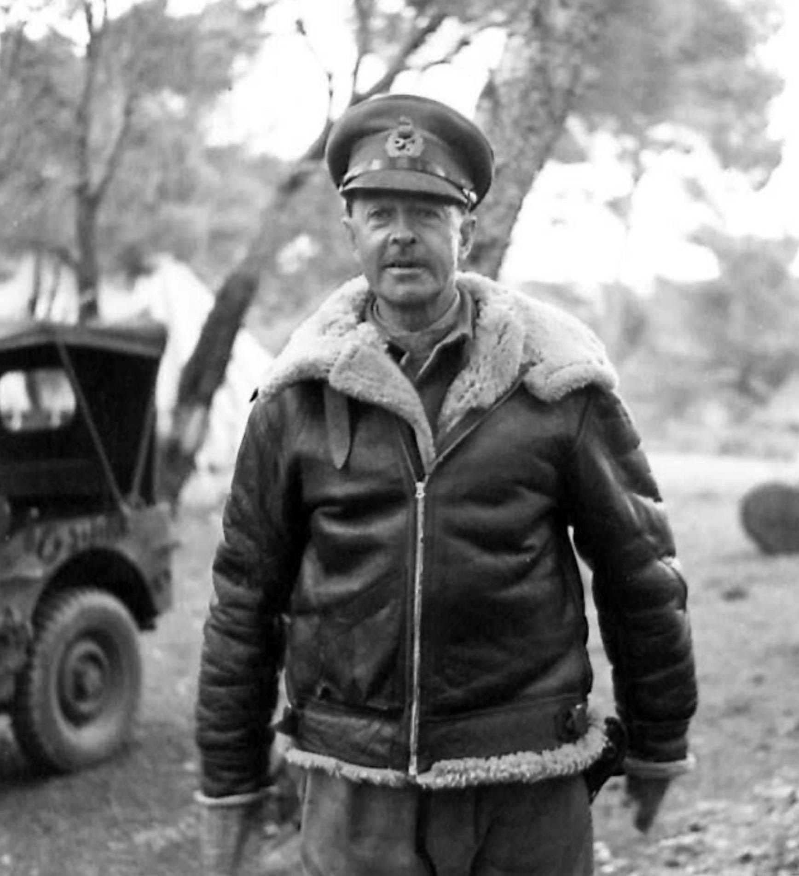
General Alexander in Tunisia in March 1943.
The Battle of Medenine
While the enemy were thus vigorously and persistently attacking in the north, Eighth Army continued to build up gradually in front of the Mareth line. This famous fortified position was inspired by the same military conceptions as produced the Maginot line in France, though the Tunisian line was later in date and incorporated ideas derived from the earlier and larger fortification.
It ran for a total length of about twenty-two miles on a course roughly north-east to south west just in front of the small town of Mareth from which it took its name; one flank rested on the sea, the other on the steep-sided Matmata mountains.
At the north-east end the Wadi Zigzaou runs in front of the line and, artificially scarped, made a first-class anti-tank obstacle. The defences themselves consisted of a system of interconnected strong-points, partly underground, reinforced with concrete.
The fire plan was well conceived to cover all parts of the front with enfilade fire of all calibres and the minefields and wire obstacles were thick and well sited. The mountains shielding the western flank are almost impassable for wheeled traffic and the one poor road which crosses them was blocked at the pass of Ksar el Hallouf.
The desert west of the mountains was considered by the French as completely impassable for any significant force; the going is most difficult and there is very little water. This appreciation had been apparently confirmed by manoeuvres held before the war. The French therefore calculated that any force which wished to invade Tunisia from Tripolitania would have to assemble in the area between Medenine and the line and launch a frontal attack.
When this had been repulsed, as was confidently expected, or while it was still in progress, the defenders would deliver a counter-attack from the area of the Ksar el Hallouf pass on to the left flank and rear of the attackers.
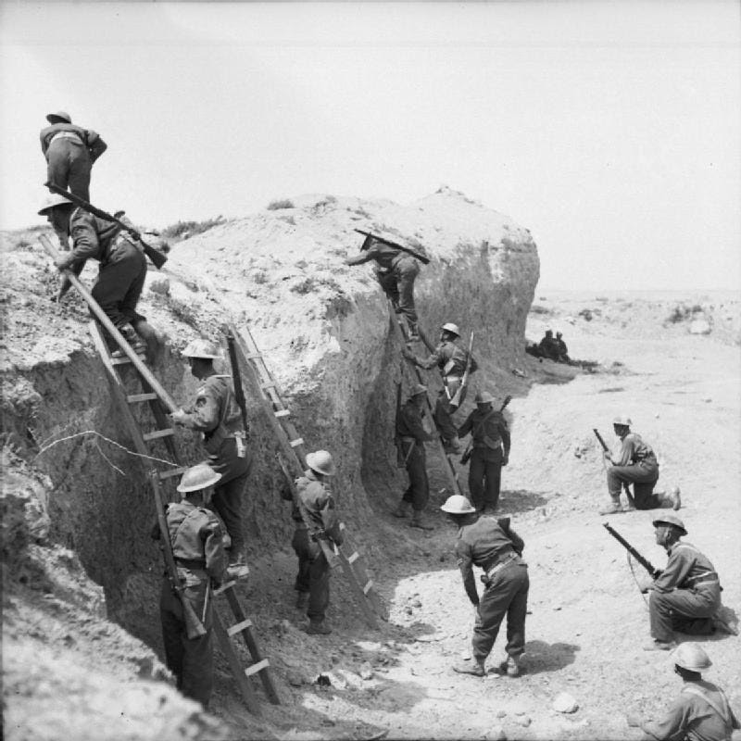
At the end of March 1943, British infantry demonstrate how they used ladders to scale the sides of Wadi Zigzuoa on the Mareth line. Before they made that attack they had to defend themselves against Rommel’s spoiling attack at the Battle of Medenine.
As I have already explained it would be some time before General Montgomery could assemble sufficient troops for an attack on the Mareth line and he was determined not to attack before he was ready.
In the meanwhile Field-Marshal Rommel still had his Army Group reserve under his hand, amounting to about two armoured divisions. They would also need a certain amount of time to recuperate from their losses in the Kasserine battle, but after that they could obviously be best used in a spoiling attack against Eighth Army.
The blow at II Corps had won the enemy a breathing space on that side and he could clearly appreciate that he would be ready to take the offensive again before Eighth Army was. I signalled to General Montgomery on 26th February to say that I thought Rommel would certainly try to attack him as soon as he could, following the original French plan; he replied in a letter on the 27th that it would be a very good thing if Rommel did attack and he only feared that he would not.
According to an eye witness on the spot Rommel was obviously a sick man, with a dirty bandage round his neck where he was suffering from desert sores; to a party who stopped near him he said that unless they won this battle the last hope in Africa was gone.
In any case Eighth Army was well poised and ready for anything; on 26th February two divisions were forward in position, the 51st to the north of the road with all three brigades up and 7th Armoured Division astride and to the south of the road. The front was covered with an armoured car screen and the area round Medenine, juncture of the Mareth and Ksar el Hallouf roads, was being organised as a defensive position.
On 26th February it became apparent that the detachment of 15 Panzer Division which had taken part in the Kasserine battle was rejoining its parent formation, and on the 28th 21 Panzer Division, and that part of 10 Panzer Division which was co-operating with it, also began to move south.
I considered therefore, that my appreciation was confirmed and so informed Eighth Army. Shortly afterwards the enemy began to thin out in Gafsa though he clearly intended to continue to block the Gafca - Gabes road at El Guettar, a defile which offered a very strong position to the defenders.
On 2nd March our aircraft on tactical reconnaissance saw large bodies of enemy transport moving south from Gabes to Matmata, at the northern end of the mountains and, although the enemy simultaneously showed us a concentration on the Mareth - Medenine road, with deceptive intent, it was clear that Rommel was going to follow the French plan and attack out of the mountains on to our left.
On the same day the New Zealand Division, which had secretly and swiftly been brought forward from Tripoli, concentrated in the area south of Medenine. On the 3rd a local attack by Italian troops on the Mareth front, which cost them severe casualties, was also probably designed to distract our attention from the west but the signs there were too strong: all that day and the next heavy movement continued in the mountains, at Toujane, Cheguimi and Ksar el Hallouf.
The enemy rested all day of 5th March and on the 6th poured down from the mountains to the attack. As the Panzer Grenadiers moved off on the evening of the 5th down the steep, winding road from Ksar el Hallouf they defiled past the Army Group Commander, standing in his open car at the top of the pass.
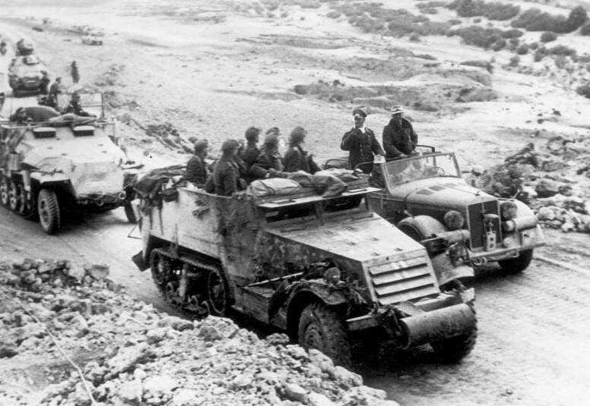
Rommel in Tunisia passed by troops in a captured US Army half-track.
According to an eyewitness on the spot, Rommel was obviously a sick man, with a dirty bandage round his neck where he was suffering from desert sores; to a party who stopped near him he said that unless they won this battle the last hope in Africa was gone.
Eighth Army was disposed with three divisions forward. On the right 51 Division, with 23 Armoured Brigade under command, covered the area north of the road,opposite the Wadi Zigzaou.To the south was 7 Armoured Division, reinforced by 8 Armoured Brigade and 1 Fighting French Flying Column. The position round Medenine was held by the New Zealand Division with 201 Guards Brigade and 4 Light Armoured Brigade under command.
The key position here was the Gebel Tadjera, a hill which rises abrupdy from the plain north-west of the town; this was defended by the Guards Brigade. The enemy’s intention was clearly the capture of Medenine, which would cut our communications with Tripoli and encircle the greater part of our forces to the north.
There had been no time to lay minefields or erect wire and our defences were based on anti-tank guns well dug in to give a short field of fire in enfilade. The enemy attacking forces were 21 and 10 Panzer Divisions from the west, with a detachment from 15 Panzer Division and some additional infantry; the remainder of 15 Panzer Division and 90 Light Division were to hold us by a frontal exploratory attack which could be converted into a genuine offensive if all went well.
That evening he drew off with the loss of fifty-two tanks, the greatest total loss he had so far suffered in one day’s battle in Africa.
The story of the battle can be told very briefly. The enemy appear to have been unaware of the strength of our positions - they expected to find Gebel Tadjera unoccupied - and probably also hoped to have escaped our notice on their long flank march.
Their concentrated attacks were beaten off by the infantry with anti tank guns, without the intervention of any of our tanks except one squadron; our casualties were light and we lost no tanks at all. The enemy made four attacks during the day, the first in the early morning mist, but in none of them was he able to score any success.
That evening he drew off with the loss of fifty-two tanks, the greatest total loss he had so far suffered in one day’s battle in Africa. It represented probably a third of the total tank strength engaged on the southern front and, perhaps nearer half of the tanks engaged in the actual attack.
In many ways this battle resembled the battle of Alam el Haifa, before Alamein: for the second time Rommel had committed the error of throwing his tanks against well-emplaced anti-tank guns. Our defensive success was a good omen for the attack on the Mareth line.
Medenine was Rommel’s last battle in Africa. Shortly afterwards (before 19th March) he handed over command of the Army Group to von Arnim. The latter was succeeded at 5 Panzer Army Headquarters by General von Vaerst who had commanded, without much distinction, 15 Panzer Division in Africa up to September, 1942.
It seems certain that Rommel’s return to Germany was genuinely due to sickness, but no doubt also the German High Command wanted to run no risk of the capture of a General with so great a reputation.

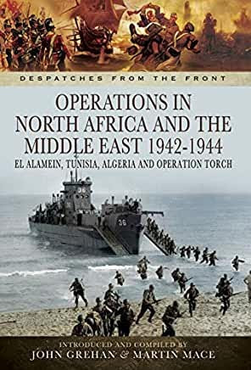
This excerpt from Operations in North Africa and the Middle East 1942-1944, El Alamein, Tunisia, Algeria and Operation Torch appears by kind permission of Pen & Sword Books Ltd. Copyright remains with the author.

